**Northwest PreOrder**

**Final Project**

**Project Report Document**

**Team Name: Code Dreamers**

Sai Praneeth Ambati

Mobile Computing –iOS , Section 44-643-05 Spring 2016

Dr. Dennis Wong

April, 2016

**App-Idea Description:**

In our school, everyone is busy in their own everyday schedule with classes, exams or job. Sometimes there might not be enough time to get the food from your favorite place because of heavy rush. Likewise, there might be different situations for us where we don’t want to stand in the line to order, pick up the food.

Considering this problem, we came up with an idea where our application will help the users (Students/Faculties) to pre-order their food. He/She can mention the preferred time to pick up, and grab the food they ordered.

**Screenshots:**

1. **Login**

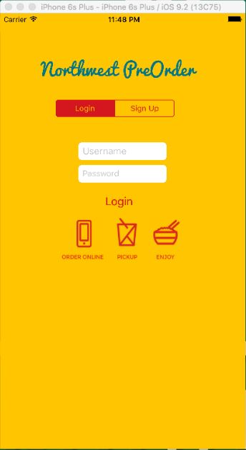

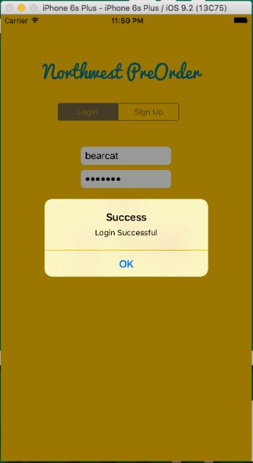

1. **Registration/Sign Up**

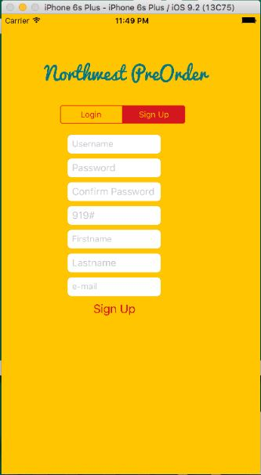

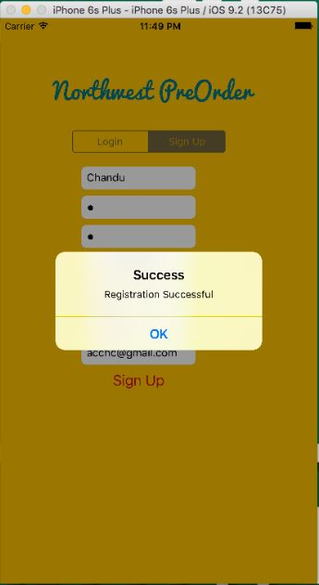

1. **Home Tab**

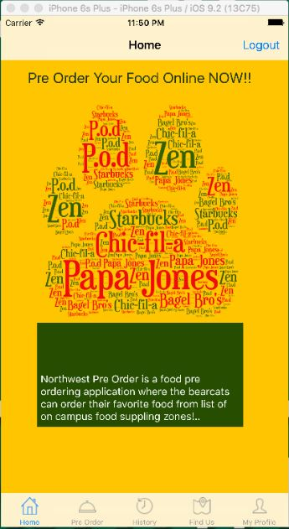

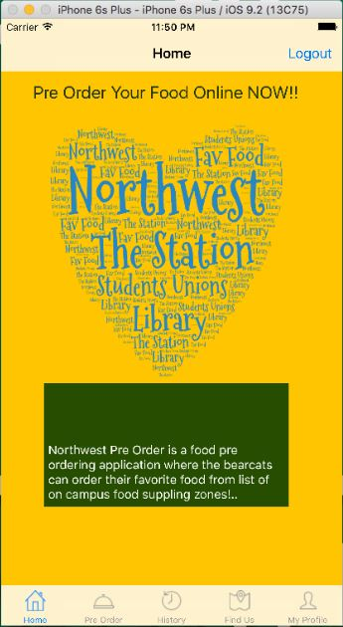

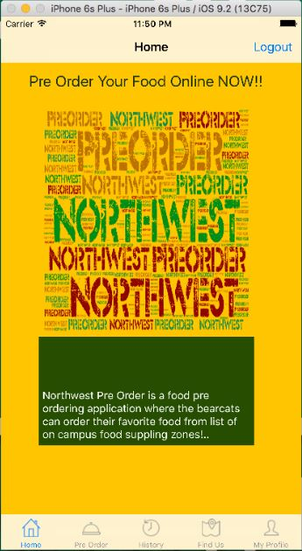

1. **Pre Order Tab**

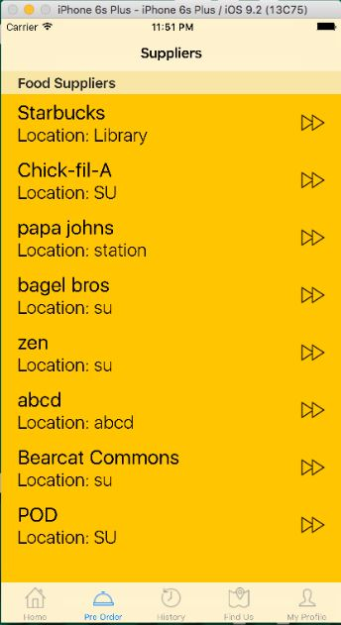

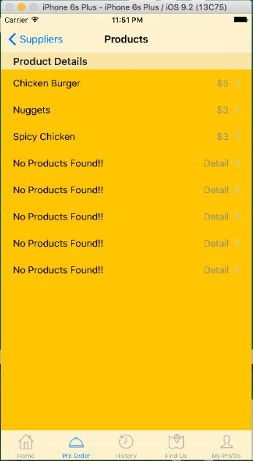

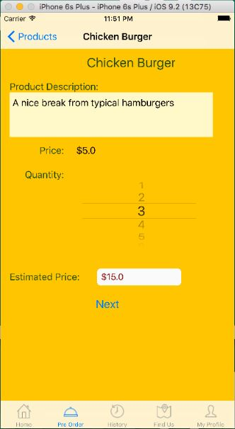

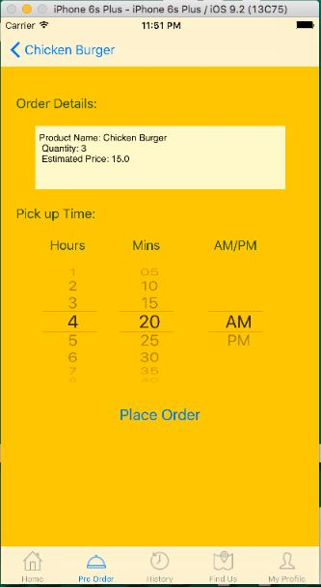

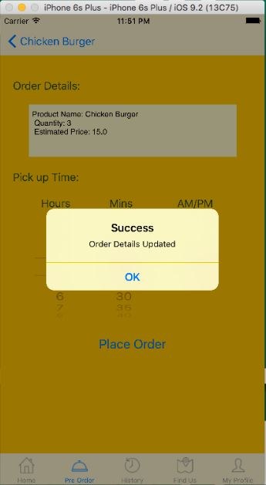

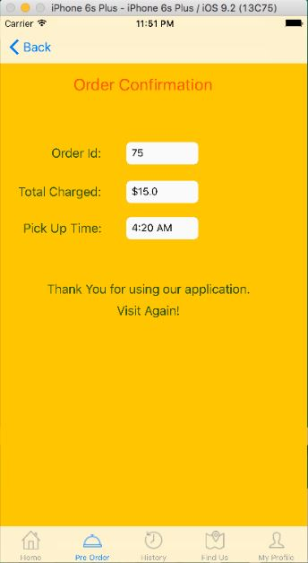

1. **Find Us Tab**

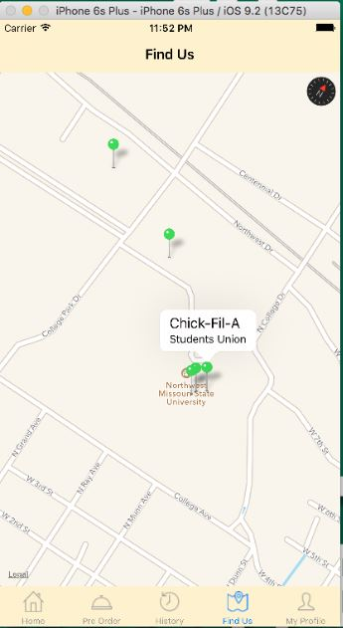

1. **My Profile Tab**

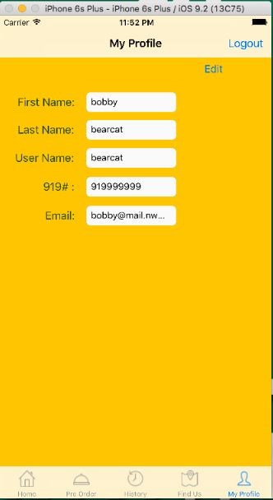

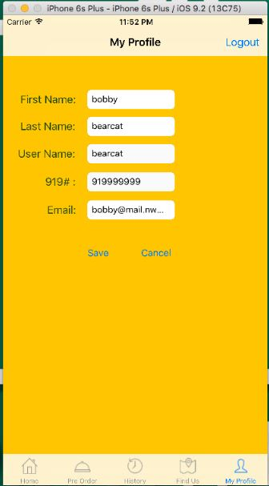

**Database:**

1. **Kinvey:**

* For Login: Username: bearcat .Password: bearcat
* New users can sign up with the application and login with their credentials.

1. **JSON Data:**

Suppliers Data: <http://codedreamers.atwebpages.com/suppliers.json>

If admin wants to add a new Supplier information: <http://codedreamers.atwebpages.com/Home.html>

Products Data: <http://codedreamers.atwebpages.com/products.json>

If admin wants to add a new product under a supplier :

<http://codedreamers.atwebpages.com/Products.html>

**Steps to run the Application:**

1. Open the project, add kinvey kit to the project.
2. Run the application with iPhone 6s plus as target device.
3. Login or Register.
4. After Login, Pre Order tab can be used to order the food.
5. To check the location click on Find Us Tab.
6. To check the account details, Click on my profile tab.